# Design Overview for Hospital Management System

Name: Nguyen Duc Thang

Student ID: 104776473

# Summary of Program

Describe what you want the program to do… one or two paragraphs.

Include a sketch of sample output to illustrate your idea.

This program will illustrate the functionality of how Hospital manage the client and also the staff inside that hospital.

Sketch:

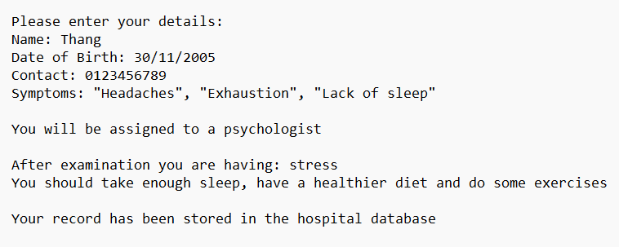

1. Design Patterns implemented in the program:

* Singleton Pattern
* Factory Pattern
* Observer Pattern
* Strategy Pattern
* Decorator Pattern

1. Complexity and additional functionalities:

In this custom program I have used the knowledge learnt from previous task as well as do some research about the design patterns and Responsibility Driven Design to implement the UML diagram which will have the flexibility to change it’s core function due to the design patterns implemented.

1. In real world medical and health are essential fields for society, with this Health Management System I implemented, It will help enhance the efficiency of the Hospital system and also can be extended to different model of hospital due to it’s versatile using the design patterns implemented into the program.
2. This is not simple compared to the D level Custom Program because it requires you to not just think about the solution for one problem but the custom program have to expand and involve for example it can be used in different library others than the dotnet framework or it can change it’s functionality depends on the user’s requirements.

# Required Roles

Describe each of the classes, interfaces, and any enumerations you will create. Use a different table to describe each role you will have, using the following table templates.

Table 1: <<role name>> details – duplicate

|  |  |  |
| --- | --- | --- |
| Responsibility | Type Details | Notes |
| _medical_staff:  _patient:  _receptionist:  _patient_record: _issue_date:  _is_valid:  _name:  _contact:  _dob:  _symptoms:  _working_hours:  _experience:  Hospital()  Manage()  PatientRecord()  Receptionist()  Person()  Patient()  Nurse()  SurgicalNurse()  PediaricNurse()  EmergencyNurse()  MedicalStaff()  Surgeon()  Pediatric()  Cardiologist()  Psychologist()  MedicalStaffFactory  TreatmentPlan  MildTreatment  AggressiveTreatment  MedicalStaffFactory  IObserver()  Doctor()  MedicalStaffDecorator()  SpecialDecorator()  EmergencyDecorator() | MedicalStaff  Patient  Receptionist  PatientRecord  DateTime  Bool  String  String  DateTime  string[]  string  string  void  void  void  void  void  void  void  void  void  void  void  void  void  void  void  void  void  void  void  void  void  void  void  void  void | Include information about doctors and nurse  Include patient information and symtoms  Include information and roles of a receptionist  Include: date and description given to the patient  Contains the day, month and year  Check if the record is from a medical staff or not  Name of patient or medical staff  Phone number of the person  Date of birth of the person  Problem the patient are having  Time that a medical staff will be on  Number of years in the job  Contains patient and medical staff data  Control how many medical staff are available and enable patient record and find it  Contains feedback given from the medical staff  Can add and remove a patient record  Abstract class represent a human information  Include patient’s personal information and symtoms  A medical staff that will update the patient record  A type of nurse will update feedback from a surgeon  A type of nurse will update feedback from a pediatric  A type of nurse will update feedback from others doctor type  Abstract class inherit from person class  Will give feedback to the patient  Will give feedback to the patient  Will give feedback to the patient  Will give feedback to the patient  Create a new Medical Staff  Give the solution based on patient’s condition  Give a mild treatment to the medical staff  Give a aggressive treatment to the medical staff  Create a medical staff  Update the data based on the input  Set treatment for patient  Allow flexible addition to the responsibility to medical staff  Use for rare patient condition that need special consultation  Use for patient with emergency issue |

Table 2: <<enumeration name>> details

|  |  |
| --- | --- |
| Value | Notes |
|  |  |

# E:\COS20007\week6\6.5HD\UML diagram with 5 design patterns.pngClass Diagram

# E:\COS20007\week6\6.5HD\Sequence diagram.pngSequence Diagram

